USER’S MANUAL
- General Description
DDS238-1 ZN type multi-function energy meter is designed to measure single phase two wire AC active energy and variable parameter. All of its functions comply with the relative technical requirement for class 1 single phase watt hour meter in IEC62053-21 and its data communication rules obey the requirement of DL/T645 or MODBUS-RTU. It is a long life meter with the advantage of high stability , high over load capability , low power loss and small volume .
The meter should be installed in suitable environment with ambient temperature range between -25℃～+55℃,the relative humidity less than 75% and temperature limits between and-40℃～+70℃.
The meter is manufactured complying with international standard IEC62052-11 on “Electricity metering equipment (AC) General requirements tests and test conditions” and IEC62053-21 on “Static meters for active energy (classes 1 and 2)”.

2.Specification and Technical Parameters
2.1Specification
Meter type | DDS238-1 ZN
Rate frequency | 50 or 60 Hz
Rated current | 5(45)A 5(32)A
Rate voltage | 120V / 220V / 230V /240V
Normal voltage range | 90%Un～110%Un
Limits voltage range | 70%Un～120%Un
Accuracy | Class 1
Pulse constant | See meter
RS485 port | MODBUS-RTU protocol, 1200～9600bps,None parity ,default 9600bps

2.2 Technical Parameters
2.2.1 Basic tolerance
Load current(A) | Power factor  (CosΦ) | Basic error(%)
Load current(A) | Power factor  (CosΦ) | 1.0 class | 2.0 class
0.05Ib | 1.0 | +1.5 | +2.5
0.1Ib—Imax | 1.0 | +1.0 | +2.0
0.1Ib | 0.5(lag) | +1.5 | +2.5
0.1Ib | 0.8(advanced) | +1.5
02Ib—Imax | 0.5(lag) | +1.0 | +2.0
02Ib—Imax | 0.8(advanced) | +1.0

2.2.2 Self-consumption
Current circuit is less than 1.5VA
Voltage circuit is less than 2W/8VA
2.2.3 Starting current
Under the rated voltage , rated frequency and COSΦ=1 , the meter shall start and continue to register on application of 0.2% In (if CT is used) or 0.4% Ib .
2.2.4 Anti-creeping
The meter has anti-creeping logical circuit. When 115%Un is connected to the meter and current circuit is cut , the meter shall not create more than one pulse in a stipulated time
2.2.5 Average-life
The meter can be used for at least 10 years in normal operation specified in this manual
2.2.6 LCD: 6+1 (999999.9 kWh)
3.Basic Features
3.1 Measuring positive & negative active energy with negative energy accumulated into positive energy,.
3.2 The meter also display three phase real voltage , real current , real active power , real power factor , real frequency
3.3 Pulse LED indicates working of meter，Pulse output with optical coupling isolation 18~27V 27mA .
3.4 RS485 communication port
3.5 Measuring active energy without calibration under long term operation
3.6 display step by step with button
4.Working principles
Single phase voltage and current are sampled from respective sampling circuit and transformed into suitable signal, which is carried into integrated circuit , then the meter output pulse signal in positive appropriation to measured power to drive step-motor counter or LCD counter to realize energy measurement. The meter has energy pulse output for testing with pulse width of 80+20ms
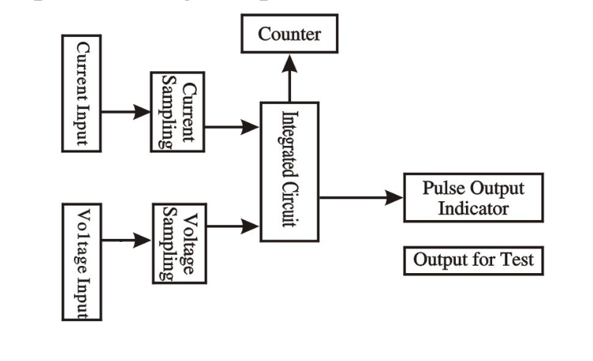
Diagram for Working Principles

5. Structure
The meter consists of meter base , meter cover , terminal base , terminal cover . there are lead seal on meter cover and terminal cover . A special screw is used to fix the terminal cover on which a lead seal can be installed
6. Usage
6.1 Connection diagram
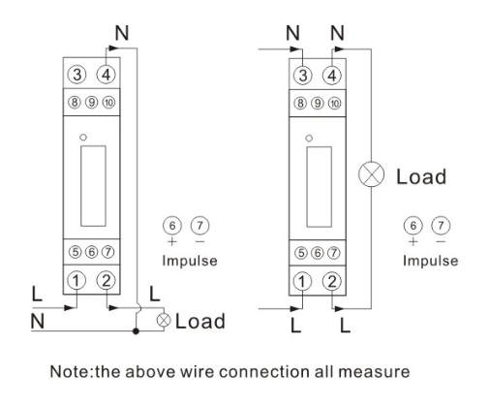
Terminal 9 and 10 is for RS485 port , 9A and 10B
6.2 Installation
The meter can be installed on a 35 mm DIN rail
6.2.1 The meter can not installed and used until it is checked goods and sealed before delivery
6.2.2 The meter should be install in the water proof box indoor or outdoor . the meter’s box should be fixed on strong and flame-resistant wall with a recommended height of about 1.8 m , where there is no corrosive gas around .
6.2.3 The meter should be install fully in accordance with connection diagram on the terminal cover, it is better to use copper as the leading wire for connection. All screws should be tightened.
6.2.4 Diagram for installation dimension
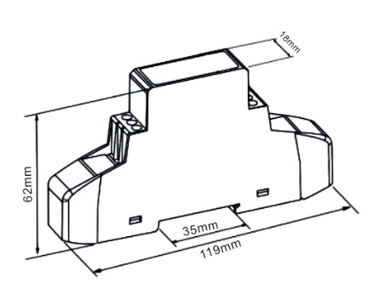
7. Transportation and Storage
7.1 Heavy impact should be burdened to the products while transportation and unpacking.
7.2 The products should be stored in the original package and kept in place with temperature between -40℃～+70℃,the relative humidity less than 75% and no corrosive gas around .
7.3 In storehouse , the meter should be placed on the shelf when kept in stock , there should not be more than 7 cartons piled up in vertical. Single-packed meters can not be piled up with more than 5 meters in vertical.

8. Warranty period
Within 24 months from the day of selling and provided that users operate correctly according to the requirement of the user’s manual , if the meter doesn’t reach its technical specification. It can be repaired or replaced in free f charge by the manufacturer .

9. Frame format
  - Read command（function code 03）
Send frame
Meter ID | Function code | Register address | Data number | Check code (CRC)
1byte | 1byte | 2byte | 2byte | 2byte

Receive frame
Meter ID | Function code | Data length n | Data area | Check code (CRC)
1byte | 1byte | 1byte | n byte | 2byte

  - Write command（function code 10）
Send frame
Meter ID | Function code | Register address | Data number | Data length n | Data area | Check code (CRC)
1byte | 1byte | 2byte | 2byte | 1byte | n byte | 2byte

Receive frame
Meter ID | Function code | Register address | Data number | Check code (CRC)
1byte | 1byte | 2byte | 2byte | 2byte

  - Energy meter register address
Register address | Data number | Data item | Data format | Data unit
0x0000 | 2 | Total kWh | XXXXXX．XX | kWh
0x0001
0x0008 | 2 | Export kWh | XXXXXX．XX | kWh
0x0009
0x000A | 2 | Import kWh | XXXXXX．XX | kWh
0x000B
0x000C | 1 | Voltage | XXX．X | V
0x000D | 1 | Current | XX．XX | A
0x000E | 1 | Active power | XXX．XXX | kW
0x0010 | 1 | Power factor | X．XXX
0x0011 | 1 | frequency | XX．XX | Hz
0x0015 | 1 | ID + baud rate | First byte is ID号，the second byte is baud rate，01~04 is means Respectively 1200、2400、4800、9600
Note 1: one register address is store 2 byte data ,so the data length read as 4 byte when data number is 2 .
Note 2:：you can use ID ID(0x00) to broadcast and got data when you do not know the meter ID. But this ways is only for 1 pcs meter to connection on RS485 wire

Address | Variable | Belong to R/W | Data format | sign | Data Model
0000H  0001H | Current total energy | R | Each electric energy kWh  occupy 4 byte XXXXXX.XX | unsigned | Dword
0002H  0003H | Reserved | Reserved | Reserved | unsigned | Dword
0004H  0005H | Reserved | Reserved | Reserved | unsigned | Dword
0006H  0007H | Reserved | Reserved | Reserved | unsigned | Dword
0008H  0009H | Current reversing energy | R | Each electric energy kWh  occupy 4 byte XXXXXX.XX | unsigned | Dword
000AH  000BH | Current forword energy | R | Each electric energy kWh  occupy 4 byte XXXXXX.XX | unsigned | Dword
000CH | Voltage | R | XXX.X V | unsigned | Word
000DH | Current | R | XX.XX A | unsigned | Word
000EH | Active power | R | XX.XXX KW | signed | Word
0010H | Power factor | R | X.XXX Kvar | unsigned | Word
0011H | Frequency | R | XX.XX | unsigned | Word
0012H | Reserved | Reserved | Reserved | unsigned | Word
0013H | Reserved | Reserved | Reserved | unsigned | Word
0014H | Reserved | Reserved | Reserved | unsigned | Word
0015H  High Byte | Communication address | R/W | 001-247 | unsigned | Char
0015H  Low byte | Communication baudrate | R/W | 01 —— 9600bps  (default)  02 —— 4800bps  03 —— 2400bps  04 —— 1200bps | unsigned | Char

- Transmission code
The information transmit in asynchronous mode in bytes. The communication information transmitting between the host computer and the slave computer is the 10 bits format , including one initial bit. 8date bit (firstly transmitting the least effective bit) . without parity check bit , 1 stop bit
- Data frame format
Address code | Function code | Data area | CRC check code
1 byte | 1 byte | N byte | 2 byte
Address code: address code is located at beginning of frame . composed of one byte (8 bit binary system code) decimal is 0-255 in the ACR meters . just 1-247 is used . other address is reserved. These bits indicate terminal device address specified by users . this device will receive the connecting host computer data. Every terminal device has only one address . only the addressing terminal respond to enquiry including this address. When terminal is transmitting one responding . the responding slave address data tell host computer that which terminal is it .
Function code : function code tell the target terminal to execute what function. Below table list . function code used in this series meters and their meaning and function .
Function | Definition | Operation
03H/04H | Read and data | Obtain current binary system value of one or multiple register
10H | Preset multi-register | Set binary system value into a series of multiple register
Data area: data area includes the data needed by terminal for executing specific function or the collected data when terminal is responding enquiry . content of these data could be value reference address or setting value . for example , the function code tell terminal to read one register . the data area need to specify the starting register and read how many data . the built-in address and data have different content depending on type and slave computer .
CRC check code : error check (CRC) domain occupies 2 byte . including one 16 bit binary system value. CRC value is calculated by transmission device. And then attached to the data frame . the receiving device . while receiving ,it calculates the CRC value again. Then comparing it with the receiving CRC domain value. If these two values are not equal . it and error occurs.。
Flow for forming one CRC：
- Preset one 16 bit register as 0FFFFH（All-1）called as CRC register
- 8 bit of data frame first byte and low byte of CRC register carry out exclusive or operation . the save its result back to CRC register .
- Right shift CRC register for one bit . the most significant bit is filled with 0 . the least significant bit is shifted out and tested .
- If the least significant bit is 0 . repeat the third step(next shift) if the significant bit is 1 .CRC register and preset fixed value specified (0A001H) carry out exclusive or operation .
- Repeat the third step and fourth step until shift for 8 times. The complete 8 bit is done .
- Repeat the second step to fifth step to treat next 8 bit until all the byte is treated .
- The CRC register final value is CRC value . besides . there is another CRC calculation method by preset table. Its main feature is fast calculating speed . but large saving space is needed . please refer to related data .
5.4.54. explain for communication applicable format
  - Function 03H：read register
This function allow user to obtain data and parameters collected and recorded by equipment . data amount of once requested by host computer have no limit . but the address should be in range .
following example is one basic data read from 01 slave (each address in data frame occupy 2 bytes) the collected data is the total electric energy E(occupy 4 bytes ) other address is 00H
  - Function code 10H ：writing register
Function code 10H allows the user to change the contents multiple registers .time ,data, rate period of time etc . in meter can be written by this function code . the one shot maximum write in data (32 bytes) of host computer is 16 .
Below meter example show : preset address 01 data ,time :12:00 , 01/02/2008
Master transmitting |  | Transmitting  information |  | Slave returning |  | Returning  information
Address code |  | 01H |  | Address code | 01H
Function code |  | 10H |  | Function code | 10H
Initial address | High byte | 00H |  | Initial address | High byte | 00H
Initial address | Low byte | 12H |  | Initial address | Low byte | 12H
Register  No. | High byte | 00H |  | Register No. | High byte | 00H
Register  No. | Low byte | 03H |  | Register No. | Low byte | 03H
Byte number |  | 06H |  | CRC check  code | High byte | 20H
0012H  Data to be  written | High byte | 08H |  | CRC check  code | Low byte | 0DH
0012H  Data to be  written | Low byte | 02H
0013H  Data to be  written | High byte | 01H
0013H  Data to be  written | Low byte | 0CH
0014H  Data to be  written | High byte | 00H
0014H  Data to be  written | Low byte | 00H
CRC check  code | High byte | FFH
CRC check  code | Low byte | A8H

Attachment：
- belong to read/write：“R” read only，read this parameter use 03H command. “R/W” readable/writable write parameter use 10H command . write in address of non-listed or no-writable address is forbidden.
- the communication address of electric energy meter is given with delivery . also read out through the software provided by our company.
- the voltage value detected by electric energy meter is fixed by 2 bit decimal number . data format is XXX.XX , unit is V . if communication read out voltage value is 55EEH（21998） , then voltage actual value is 219.88V. the measured current value is fixed by 3 bit decimal number . data format is XX.XXX unit is A . if communication read out current value is 05DBH（1499），then current actual value is 1.499A
- the active and reactive power value by electric energy meter is fixed by 2 bits decimal number . data format is XXX.XX ,unit is kW(kvar)。If communication read out the active and reactive power value is 0020H（0032）, then the active and reactive power actual value is 0.32kW(kvar) ,the apparent power value is fixed by 1 bit decimal number . data format is XXXX.X unit is VA. If communication read out the apparent power actual value is CE44H（3300），then the apparent power actual value is 330.0VA
- the electric energy value measured by electric energy meter occupy 4 bytes. Unit is kWh . the high bit is before the low bit . if reading value is 0012D687H（1234567），then the electric energy metering value is 1234567x0.01=12345.67kWh
- order of 14-period of time parameter setting information of above address table

example:
read address which address is 0 ：0
send
00 03 00 15 00 01 94 1F
reply
00 03 02 00 02 04 45

EXAMPLE
read the meter which address is 1

read the total energ which the energy is 10 kWh
send
01 03 00 00 00 02 c4 0b
reply
01 03 04 00 00 03 e8 crc16

read the real voltage which is 220V
SEND
01 03 00 0c 00 01 44 09
REPLY
01 03 02 08 98 crc16

READ REAL CURRENT WHICH IS 5A
SEND
01 03 00 0d 00 01 15 c9
REPLY
01 03 02 01 f4 crc16

READ ACTIVE POWER WHICH IS 10.5 KW
SEND
01 03 00 0e 00 01 crc16
REPLY
01 03 02 29 04 crc16

READ REACTIVE POWER WHICH IS 0.5 KVAR
SEND
01 03 00 0F 00 01 crc16
REPLY
01 03 02 01 F4 crc16

READ THE POWER FACTOR WHICH IS COS 0.99
SEND
01 03 00 10 00 01 crc16
REPLY
01 03 02 03 de crc16

READ FREQUENCY WHICH IS 50.5
SEND
01 03 00 11 00 01 crc16
REPLY
01 03 02 13 ba crc16

Example change address

Change address 01 to 02 and baudrate to 9600

Send code 0110H 0015 0201 58AE

01 = address

10H = function write

0015 = register address

0201 = change address to 02 and baudrate to 9600

58AE = check sum

10. Display item
 | INFORMATION | LCD DISPLAY
01 | Meter ID | ID 001 | ★
02 | Real voltage V | U 000.0 | ★
03 | Real current A | A 00.00 | ★
04 | Real power W | P 0.0 | ★
05 | Power factor COSФ | PF 0.00 | ★
06 | Real frequency Hz | F 00.00 | ★
07 | Total energy kWh | 000000.0 | ★
08 | Positve kWh | 000000 | ☆
09 | Reverse kWh | -000000 | ☆
10 | Reset energy | EP0000.0 | ☆

Note: ★Standard function ,☆special order function (It will reset energy to zero, after you pull the button last 10s,if you have order reset function)

